A user’s manual containing instructions of compiling and executing our software

step1: Download SWI-prolog from the following website:

[www.swi-prolog.org/Download.html](http://www.swi-prolog.org/Download.html)

step2: write click on the file “dietician.pl” and open with SWI-Prolog

step3: type “solve(dietician(X)).” and Enter.

step4: you will be the following help screen which shows you how to use the expert system.

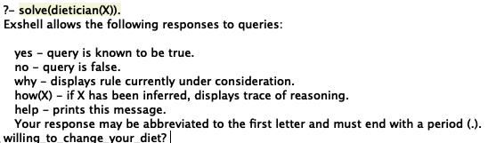

step 5: you can choose y for yes or n for no or w for why or how(X) or help for the same screen.

(do not forget to put ”.” at the end of each of your answers.)

step 6: First, the system needs to make sure that you are willing to make a change in your diet. If you answer no then it will give you some general nutrition tips and exits.

step7: Then, if you need help with weight_loss, you put “y.” otherwise you type “n.” to get the next option and so on as you see:

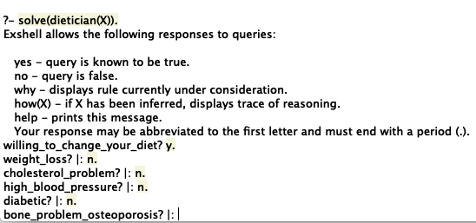

step8: Then based on your answer to a series of questions, the system gives you some dietary advice which fits your needs.

step9: At the end you have the option of tracing your answer.